**Question 1:** Desribe the datatypes of SQL server along with some examples.

 **BAHRIA UNIVERSITY (KARACHI CAMPUS)**

**ASSGINMENT # 1 - SPRING 2020**

# DATABASE MANAGEMENT SYSTEM (CSL-220)

Class: **BSE 4(A/B)**

Course Instructor: **Engr. Bushra Fazal Submission Deadline: 18th March, 2019**

Lab Instructor: **Engr. Saniya Sarim** Max Marks: **20**

Student’s Name : **SYED ALI ABBAS** Enrolment No. **02-131182-070**

**Answer:** There are many datatypes of sql. Some commonly used datatypes are listed below

* **varchar and nvarchar** – Both used for storing strings, nvarchar is used when we have to save multiple languages’ data. And varchar store single language’s data. We have to give words limit with this type.

**Example:**

CREATE TABLE Persons (  
    **LastName varchar(255),  
    FirstName varchar(255),  
    Address varchar(255),  
    City varchar(255)**  
);

* **int –** Used to store integer values.

**Example:**

CREATE TABLE Persons (  
    **PersonID int,**  
    LastName varchar(255),  
    FirstName varchar(255),  
);

* **decimal** – Used to store integer values . It also requires precision and scale value. Precision is the number of total digits and scale is the number of digits after the point.
* **Decimal(5,2)** will have 3 digits before point and 2 digits after it. Like **534.31.**

**Example:**

CREATE TABLE materials (

    id INT AUTO_INCREMENT PRIMARY KEY,

    description VARCHAR(255),

    cost DECIMAL(19 , 4 ) NOT NULL);

* **numeric –** Same as decimal.

**Example:**

CREATE TABLE  account (

accountNo integer,

**balance numeric(8,2));**

**Note:**

Similarly there are many other datatypes of SQL server such as Float, Date, Time and Binary etc.

**Question 2:** Perform the following queries on SQL server and provide output.

1. Replace “Rd.” in Address Column with “Road” in employee table. Hint : Using replace keyword

https://lh4.googleusercontent.com/wmqmIPRqN8ZOSaRpdsZGcfSn_Dx7FVJ44wt0VzinLP7b7Aybyqe8DdfecvGgYKx0F-YpbHOKBJIoe_KYxylib7T16vBDC4xcYasuMWRqVPUMvF4JMVuc7snqyIRz63CKN9kHAhYX

**Query:**

select address, replace('4110 Old Redmond Rd.', 'Rd.', 'Road') as Modified_Address from Employees where address like '4110%'

**Output:**

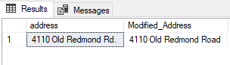

1. Select only first letter from Title in Employee table

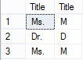

**Query:**

SELECT titleofcourtesy , SUBSTRING(titleofcourtesy, 1, 1) AS Title from employees;

**Output:**

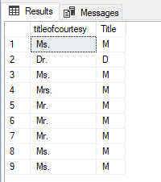

1. Write a query fetch months from BirthdDate, -- Hint: Convert datatype of Birthdate from datetime to nvarchar.

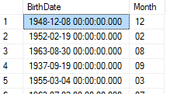

**Query:**

select birthdate ,  datepart(month FROM birthdate ) as [month] from employees

**Output:**

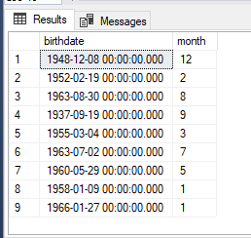

1. Concat the firstname, lastname and hiredate of employees like mention below and list them under the Information heading.

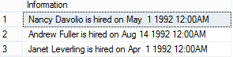

**Query:**

SELECT CONCAT(FirstName, ', ', LastName, ' is hired on ', hiredate) AS information FROM employees;

**Output:**

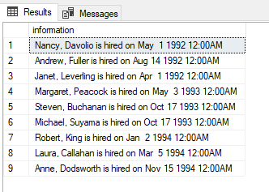

1. List employee’s FirstName and their length as follows.

https://lh6.googleusercontent.com/zRJXR9w3orCq1PmOY9ePm_uEWtfIZ6iNMqKUdwVtWDra2Vb0nKX_dJ9ssNgVZW-f_dpJf1zuNlOnuZneUICK9hUmS6WGq4ZOwVzdw8zsdqp3zZL4MYNoUp1MVIsi40UwDucHo6WM

**Query:**

SELECT firstname, LEN(FirstName) AS Length_Of_FirstName from employees;

**Output:**

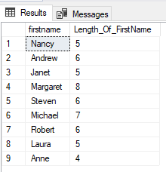

1. Count all orders against each product id, if no of orders are greater than 50.

https://lh5.googleusercontent.com/Fa8j1d6W3GSgJc6i9O-WfCHB0ULvgeLrI97V0Po0xem2oqVNyCoPN7vYvxMFXT6hjuVgCJUyguQsRaLM5rgqed4ZTLtTMmhpN1z_QxtMbzyS1UBXxt5wECq8FujuDxJsq3e1Pf8Y

**Query:**

select ProductID, count(quantity) as Orders from [Order Details] group by ProductID having count(Quantity)>50

**Output:**

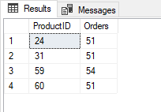

1. Write a query to list Maximum UnitPrice of each category where CategoryID lies in the range of 2 - 6 and Maximum Unit Price is greater than 55.

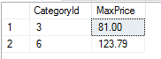

**Query:**

select distinct CategoryID, max(UnitPrice) as MaxPrice from Products where CategoryID between 2 and 6 and UnitPrice>55 group by CategoryID

**Output:**

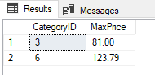

1. Write a query to list all employees that match following condition

- Title doesn’t contain Manager and

- Region should be equals to WA

-TitleofCourtesy  can be either Dr. or Mrs.

https://lh4.googleusercontent.com/D_ZQjKe_e6zFgHfe4Y-qVUyWBtSn9DcIw6jGKUrpMfbXUt77NWg-aZfpglqJoD_PcycTAhqsuAhfL5QkTKrMI_swtd16GK1SeCWNNdCQCOoUnm5Xzw0UjCryPFDBafPdFks2sYB3

**Query:**

select firstname, title, titleofcourtesy from Employees where title not like '%manager%' and region  like 'wa' and (titleofcourtesy='dr.' or titleofcourtesy='mrs.');

**Output:**

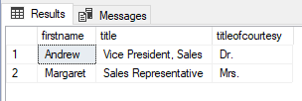

1. Write a query to count no of distinct cities in each country.

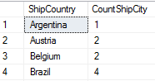

**Query:**

select shipcountry, count(distinct(shipcity)) as Count_Ship_City from Orders group by shipcountry;

**Output:**

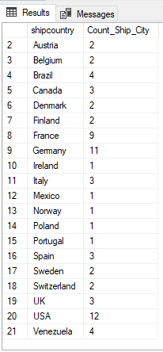

1. List only those cities in which 2 or more than 2 employees are living.

https://lh3.googleusercontent.com/T4mJwYbl2TWdRO2jqGO0puLbBu7q0XZVivRhnOwe-CxUJm2J9rtAx7DcxDV2fgsWZhhubJAFI08dAgWEQUBlGh2tlQ-gIuMNgs7JvsKXy3lEY5UE2pBNba3AdOr7Vyc6lZocWnY7

**Query:**

select city, count(employeeid) as Employee_Living from employees group by city having count(EmployeeID)>=2;

**Output:**

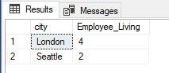

|  |  |  |  |
| --- | --- | --- | --- |
| Salesman_ID | Name | City | Commission |
| 5001 | James Hooq | New York | 0.15 |
| 5002 | Nail Knite | Paris | 0.13 |
| 5005 | Pit Alex | London | 0.11 |
| 5006 | Mc Lyon | Paris | 0.14 |
| 5003 | Lauson Hen |  | 0.12 |
| 5007 | Paul Adam | Rome | 0.13 |

**Question 3:** Solve the queries in SQL server given below by following this table:

1. Write a query to produce a list of salesman_id, name, city and commision of each salesman who live in cities other than Paris and Rome.

**Query:**

select * from salesman where city<>'paris' and city<>'rome';

**Output:**

https://lh4.googleusercontent.com/h0FXLP7enRHadNIzSWqzvJCfHZ0hKvZWiLMQ0_cN1y87huE-0J0bwkIOXNBe2-MS2gBAKy0nnWjOXU9EMsuaPRf8hovx2N_ijAYi-UXRoPw7E06hH7J2H8ieeECYo_X6DBtusX2o

1. Write a SQL statement to find those salesmen with all other information and name started with any latter within 'A' and 'K'.

**Query:**

select * from salesman where Name between 'A' and 'K'

**Output:**

https://lh5.googleusercontent.com/P3sqm6zg9JcH21FdiZGJcNqDrQ1Tt7RX2e83E9UGWAtZDVU2j6xs4uIoIdRr3ICvL8brSuGbyeV692s1B2iG0oAvUw9CfKXsGhytNWBv2aUgjcxywUWT8C9SMNQTwZ4vo0AA9Enf

1. Write a SQL statement to find all those customers with all information whose names are ending with the letter 'n'.

**Query:**

select * from salesman where Name like '%n'

**Output:**

https://lh4.googleusercontent.com/-LUHYNX8tf5V-Qk4-jFsJbP7Sl-azV4vXuaa0CDHQeT8USGaYVLYGD7zx-mqanUN9ktxNOwrDP0rQe56YgH3z3YrE0va0m3E3BNox4zbehM7DVxR5L8iKcYSLdWcuPiKBNe6UQd0

1. Write a SQL statement to find those salesmen with all information who come from the city either Paris or Rome.

**Query**:

select * from salesman where city='Paris' or city='Rome';

**Output:**

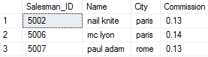

1. Write a SQL statement to find those salesmen with all information who gets the commission within a range of 0.12 and 0.14. Write a SQL statement to find those salesmen with all information whose name containing the 1st character is 'N' and the 4th character is 'l' and rests may be any character.

**Query:**

select * from salesman where commission between 0.12 and 0.14;

**Output:**

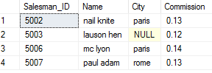

**Question 4:** Solve the queries in SQL server given below by following this table:

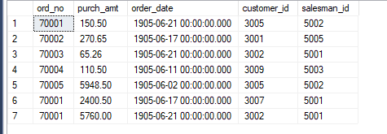

1. Write a SQL statement to find the average purchase amount of all orders.

**Query:**

select avg(purch_amt) AS AVG_PURCHASE_AMOUNT from orders;

**Output:**

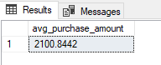

1. Write a SQL statement to find the total purchase amount of all orders.

**Query:**

select sum(purch_amt) AS total_PURCHASE_AMOUNT from orders;

**Output:**

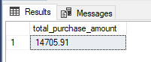

1. Write a SQL statement to get the minimum purchase amount of all the orders.

**Query:**

select min(purch_amt)AS MIN_PURCHASE_AMOUNT from orders;

**OUTPUT:**

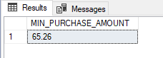

1. Write a SQL statement to get the maximum purchase amount of all the orders

**Query:**

select max(purch_amt)AS MAX_PURCHASE_AMOUNT from orders;

**Output:**

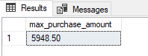

1. Write a SQL statement to find the highest purchase amount with their ID, for only those customers whose ID is within the range 3002 and 3007.

**Query:**

SELECT customer_id,MAX(purch_amt) as [Highest Purchase Amount]

FROM orders WHERE customer_id BETWEEN 3002 and 3007 GROUP BY customer_id

**Output:**

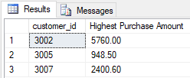

1. Write a SQL statement to find the highest purchase amount with their ID and order date, for only those customers who have highest purchase amount in a day is more than 2000.

**Query:**

SELECT customer_id,ord_date,MAX(purch_amt) as [Highest Purchase Amount]FROM orders GROUP BY customer_id,ord_date HAVING MAX(purch_amt)>2000.00;

**Output:**

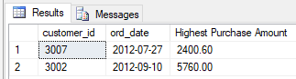

**Question 5:** Solve the JOIN queries in SQL server given below by following this table:

Table: Orders

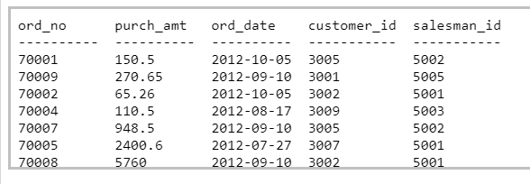

Table: Customer

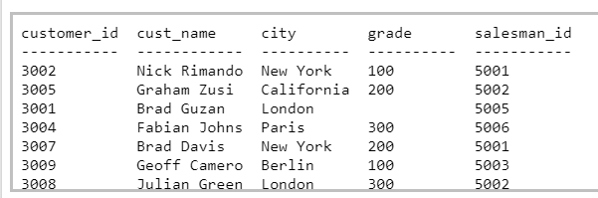

Table: Salesman

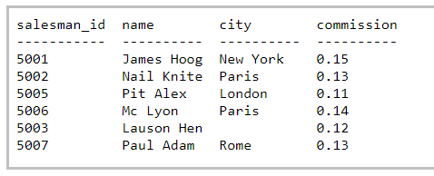

1. Write a SQL statement to make a list with order no, purchase amount, customer name and their cities for those orders which order amount between 500 and 2000.

**Query:**

SELECT  a.ord_no,a.purch_amt,b.cust_name,b.city FROM orders       a,Customers b WHERE a.customer_id=b.customer_id AND a.purch_amt BETWEEN 500 AND 2000;

**Output:**

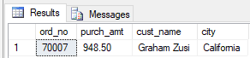

1. Write a SQL statement to make a report with customer name, city, order number, order date, and order amount in ascending order according to the order date to find that either any of the existing customers have placed no order or placed one or more orders.

**Query:**

SELECT a.cust_name,a.city, b.ord_no,b.ord_date,b.purch_amt AS "Order Amount" FROM Customers a LEFT OUTER JOIN orders b ON a.customer_id=b.customer_id order by b.ord_date;

**Output:**

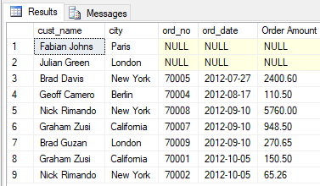

1. Write a SQL statement to make a report with customer name, city, order no. order date, purchase amount for those customers from the existing list who placed one or more orders or which order(s) have been placed by the customer who is not on the list.

**Query:**

SELECT a.cust_name,a.city, b.ord_no,b.ord_date,b.purch_amt AS "Order Amount" FROM Customers a FULL OUTER JOIN orders b ON a.customer_id=b.customer_id;

**Output:**

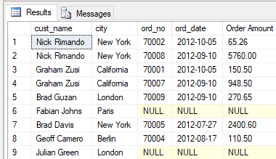

1. Write an SQL statement to prepare a list with salesman name, customer name and their cities for the salesmen and customer who belongs to the same city.

**Query:**

select s.name AS "Salesman",c.cust_name, c.city FROM Salesman s ,Customers c WHERE s.city= c.city;

**Output:**

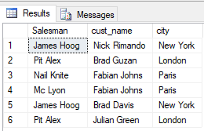

1. Write a SQL statement to know which salesman are working for which customer.

**Query:**

select c.cust_name , s.[name] as salesman_name  from customer c inner join salesman s on c.salesman_id=s.salesman_id

**Output:**

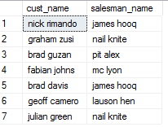

1. Write a SQL statement to make a list in ascending order for the customer who works either through a salesman or by own.

**Query:**

select c.cust_name , s.[name] as salesman_name  from customer c left join salesman s on c.salesman_id=s.salesman_id order by c.cust_name

**Output:**

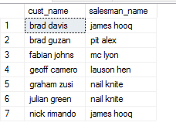

1. Write a SQL statement to make a Cartesian product between salesman and customer i.e. each salesman will appear for all customer and vice versa.

**Query:**

select c.cust_name as customers, s.[name] as salesman from salesman s cross join customer c

**Output:**

